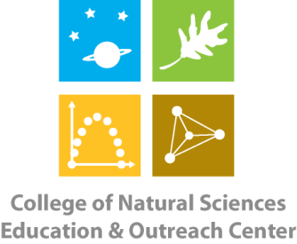
College of Natural Sciences
Education & Outreach Center
Colorado State University
B301 Natural & Environmental Sciences Building
Fort Collins, CO 80523-1802
970-491-1700
970-491-2005 - FAX

CNS Education & Outreach Center Solar Car STEM Kit Request Form

Requesting School/Organization:
Contact Name: Phone Number:
Email Address:
Check-Out Date: Return Date:
A classroom set (15 individual kits) of the Solar Car STEM kit* is available for checkout from the CNS EOC for teacher/workshop use. Each individual kit contains the following items:
- 1 Instruction Booklet
- 1 Solar Panel
- 1 Motor
- 1 Roll of Duct Tape
- 1 Piece of Corrugated Plastic
- 1 Motor Mount
- 1 Ruler
- 1 Pair of Scissors
- 1 Pair of Pliers
- 6 O-Rings (various sizes)
- Eye Screws, Push Pin, Rubber Spacers, Bushings, Motor Pulley, Worm Gear (in plastic jar)
- Pulleys (various sizes)
- 4 Wooden Wheels & 2 Yellow Plastic Wheels
- 5 Gears (various sizes)
- 1 Propeller
- 1 Sandpaper Square
- 3 Rubber Bands (various sizes)
- 2 Wooden Dowels & 2 Wooden Blocks
- 1 Velcro Square & 2-4 Double Stick Tabs
*Teachers must provide students with corrugated plastic or cardboard, Velcro squares, double stick tabs, wooden dowels & blocks, a test lamp and rubber bands as needed.

By signing below, I agree to handle the above materials with care and to return them to CNS EOC in the same condition as I checked them out in and by the above stated date (or earlier). I understand that if a piece of equipment becomes damaged or lost (unless it is a consumable) while in my care, I will be responsible for replacing it.

Signature Date

