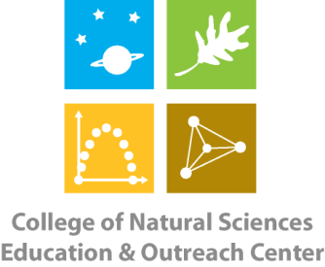
College of Natural Sciences
Education & Outreach Center
Colorado State University
B301 Natural & Environmental Sciences Building
Fort Collins, CO 80523-1802
970-491-1700
970-491-2005 - FAX

CNS Education & Outreach Center Small Fish – Big Questions STEM Kit Request Form

Requesting School/Organization:
Contact Name: Phone Number:
Email Address:
Check-Out Date: Return Date:

A classroom set (15 individual kits) of the Small Fish – Big Questions STEM kit is available for checkout from the CNS EOC for teacher/workshop use. Each individual kit contains the following items:

- 1 Instruction Booklet
- 1 USB Memory Stick
- 2 Observation fish tanks with mesh lids
- 1 Magnifying glass
- 1 Guppy photo card
- 1 Clear metric ruler
- 2 Guppy stencils
- 1 Cichlid silhouette
- 1 Four sided die
- 1 Red pad of sticky notes
- 1 Blue pad of sticky notes
- 1 Spray bottle of ethanol
- 1 Pack of 8 colored pencils
- 1 Mechanical pencil
*Teachers must provide students with computers and paper towels.
The teacher kit contains:
- 3 populations of guppies
- 3 fish nets
- 1 bottle of oxygenation tablets
By signing below, I agree to handle the above materials with care and to return them to CNS EOC in the same condition as I checked them out in and by the above stated date (or earlier). I understand that if a piece of equipment becomes damaged or lost (unless it is a consumable) while in my care, I will be responsible for replacing it.

Signature Date

