School Water Budget
Student Worksheets

Version 2.4

Table of Contents
School Map – page 2
Evaporation – page 4
Transpiration – page 5
Infiltration – page 7
Runoff – page 10
School Construction Site – page 11
Fertilizer – page 12
Tracing Pathways – 13
School Map Formative Assessment
Below is a map of a school campus.
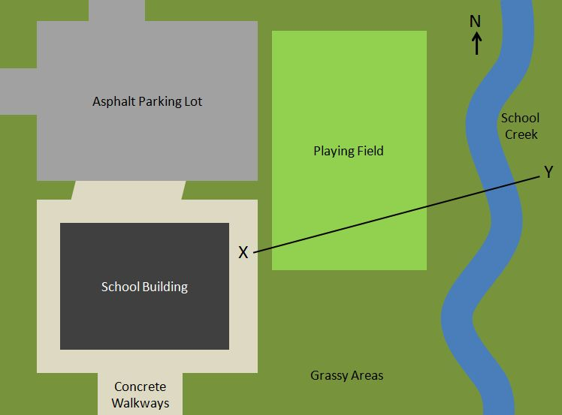

1. If you were looking from the side instead of from above, what would the shape (height) of the land be like across the distance from Point X to Point Y? (Circle the answer you think is the best.)
A |  | D | 
B |  | E
C | 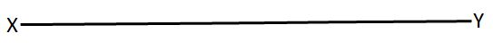 | F | There’s no way to know.

Explain your reasons for your answer.

__________________________________________________________________________________________________________________________________________________________________________________________________________________

2. Circle which direction you think School Creek is flowing:

a. North b. South c. You can’t tell from the map

Explain how you know.

______________________________________________________________________

______________________________________________________________________

Evaporation Instructions and Data Sheet

1. Your team is responsible for an evaporation pan.
2. Fill your pan half full with water.
3. Use duct tape to attach window screen to cover the pan (to prevent animals from drinking the water). Put the tape on in such a way that you can open the top to take a measurement each day.
4. Place outside in a carefully chosen location. (Shade, full sun, calm wind, full wind. Avoid sprinklers.)
5. Use the ruler to measure the height of the water at the edge of the pan in the same place each time (in case the pan in not exactly level). Measure to the nearest 1/8”.
6. Revisit your pan the next day to measure and record water height.

Month:
Site Description:

Pan Location | Day 1  (inches) | Day 2  (inches) | Evaporation Rate  (Day 2 – Day 1)  (inches/day)

Extrapolate your evaporation rate to a year by multiplying by 365.

Annual Evaporation
(inches/year)
Transpiration Formative Assessment

What happens to water inside a plant?

Six friends are walking through their neighborhood when they notice someone watering their garden. One friend asks: What happens to the water that enters the plants?
Michael responds: The plant stores the water
Jason responds: The water will eventually come back out into the soil
Tonya responds: The water leaves the plant as a gas
Juanita responds: The water makes the plant live and grow.
Charles responds: The plant evaporates the water
Who do you agree with the most and why? If you disagree with all the responses, please provide your own response.
Which student do you agree with the most? ______________________________
Why? ________________________________________________________________________________ __________________________________________________________________________________________________________________________________________________________________________
If you disagree with all of the provided responses, provide your own answer to the question, “What happens to the water that enters the plants?” _________________________________________________________________________________________________________________________________________________________________________________________________________________________________________________________________________________________________________________________________________________________________________________________________________________________________________
Transpiration Instructions and Data Sheet

1. Label the bag with a sharpie marker with your team’s name.
2. Go outside and find a suitable tree with limbs you can reach.
3. Place a baggie over a batch of leaves or needles of similar size and use duct tape to tightly seal it around the stem. You might have to remove some leaves or needles where you attaché the duct tape to make a tight seal. Also, make sure the top of your baggie is higher than the bottom to prevent leaks.
4. Count or estimate the number of leaves or needles in your baggie.
5. Return to the tree the next day, carefully remove the baggie without spilling any water that accumulated.
6. Use a 25 mL graduated cylinder to measure the volume of water collected.
7. Divide your result by the number of leaves or needles in the baggie and then multiply by the estimated number of leaves or needles on the tree.

Month:
Site Description:

Tree Type:

Number of leaves or needles in baggie | Volume of water measured (mL) | Volume of Water from 1 leaf or needle (mL) | Estimated number of leaves on tree | Total amount  transpired per day
Infiltration Formative Assessment
1. Start by drawing and labeling what you think it looks like underground.

2. A plastic tube is pressed into the ground and water is poured in. Next, use a combination of arrows and labels to show where water goes if it were allowed to drain out the bottom of the tube.

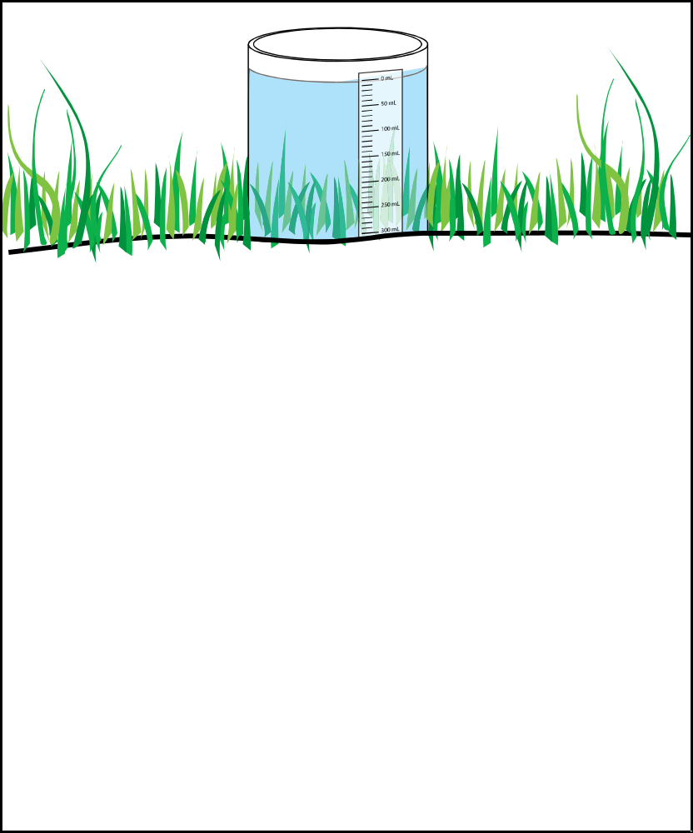
Infiltrometer Instructions and Data Sheet

1. We need to place the infiltrometer on the surface you want to test and make a good seal. In sand or loose soil, simply push the tube into the ground. In hard packed soil or gravel, you may need to twist, push harder, or wet the soil a tiny bit. On concrete, asphalt, or roofing shingles you will need to create the seal with a 25 cm long ‘snake’ made out of the modeling clay. The snake should be about 1 cm in diameter.

2. Find a spot on the ground that is smooth and free of plants. Have someone in your group get ready to write down the numbers you read off once the experiment begins.

3. Use the bucket of water to fill the infiltrometer up to the 0mL mark then quickly start the stopwatch. Every 15 seconds, read and record the water level.

4. Plot your results on the graph below.

5. Repeat test on two different types of surfaces.

6. Rank your three surfaces by permeability and be prepared to share with the class.

Infiltrometer Data Sheet
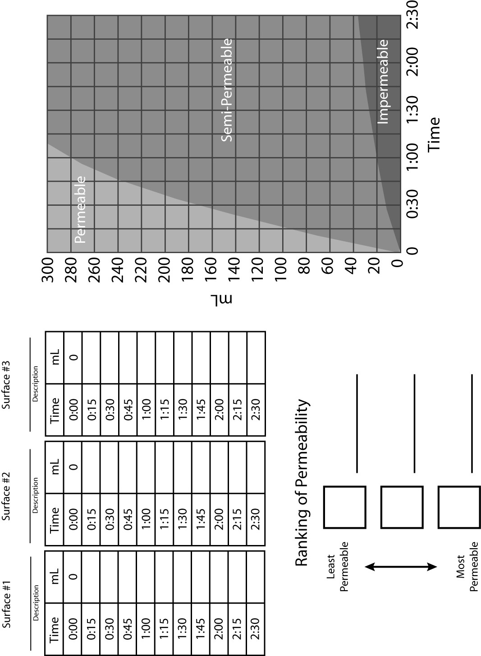
Runoff Formative Assessment

River Cleanup

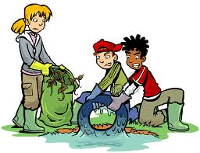

Alberto, Brenda, Cheng, Deja, and Elan were volunteering for the annual river clean-up in their town. They were finding lots of plastic water bottles, tires, shoes, and other garbage in the river. As Elan put yet another plastic water bottle in their trash bag, he asked, “If we didn’t pick this bottle out of the river, where do you think it would go?” Everyone had an idea.
Alberto: Maybe the bottles follow the water from this river to a smaller river.
Brenda: I think the bottles float downstream.
Cheng: I think the bottles float away.
Elan: Well, the bottles could go to the town of Pueblo Rio. The river in Pueblo Rio is connected to this creek.
Deja: I disagree because Pueblo Rio is up in the hills. This river goes to the town of Sweetwater, which is in the lowlands.
Who do you agree with most? _____________________
Explain your reasons. If you agree with no one, please write your own answer to the question.

Construction Site Formative Assessment

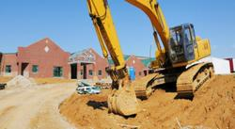

A school is doing a construction project and had to dig up some of the ground around the school. The project left a lot of dirt exposed on the surface of the ground. One problem is that when it rains, the rain could wash away a lot of the dirt exposed by the construction project. In a rain storm, where might the dirt go?

For each choice below, decide if the dirt would go there, circle YES or NO, and then explain your answer.

Could the dirt get here? | YES or NO (Circle one) | Explain your answer
- Groundwater | YES or NO
- A nearby creek that runs by downhill from the school | YES or NO
- Inside trees and plants in the undisturbed areas around the school | YES or NO

Fertilizer Assessment

Here is a map of a school campus. | 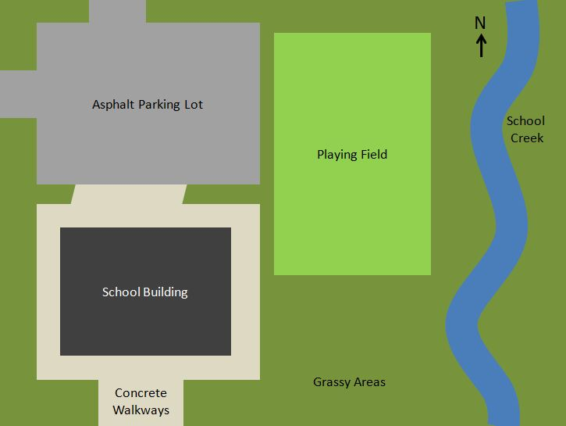

The person who takes care of the school grounds spread fertilizer on the playing field grass one Friday morning. That Friday afternoon it rained and some of the fertilizer on the grass mixed with water and lay in puddles on the playing field.  Where do you think the fertilizer could end up? | 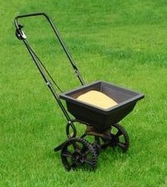

- Do you think the fertilizer mixed with water on the playing field could get into the atmosphere and come back down as rain with fertilizer mixed into it? YES NO
If you think yes, explain how. If you think no, explain why not.

- Do you think the fertilizer mixed with water on the field could get into School Creek? YES NO
If you think yes, explain how. If you think no, explain why not.

- Do you think the fertilizer mixed with water on the field could get into the groundwater? YES NO
If you think yes, explain how. If you think no, explain why not.

- Do you think the fertilizer mixed with water could get inside of grass on the playing field? YES NO
If you think yes, explain how. If you think no, explain why not.
Tracing Pathways and Processes (Relative Amounts)

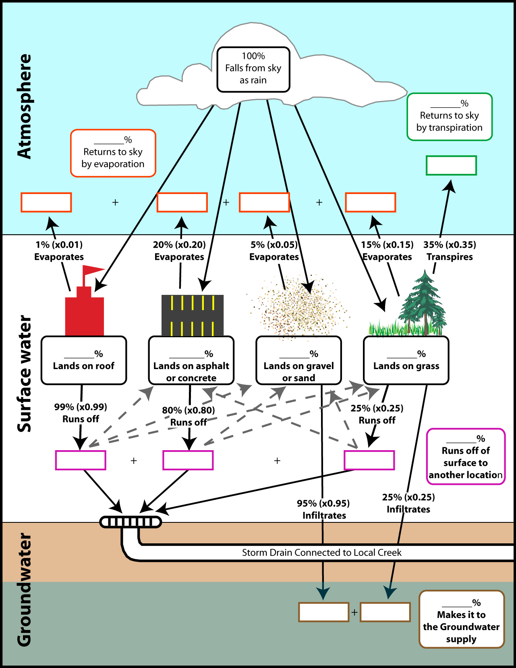
Tracing Pathways and Processes (Absolute Amounts)



